Python loops (for/while)
- Write a Python program to construct the following pattern, using a nested for loop.

*
* *
* * *
* * * *
* * * * *
* * * *
* * *
* *
*

- כתוב תוכנית שקולטת מספרים עד שהמשתמש יכניס את המילה "done". על התוכנית לספור ולהציג כפלט את כמות המספרים הזוגיים ואת הכמות המספרים האי-זוגיים שהוכנסו.

דוגמת הרצה:
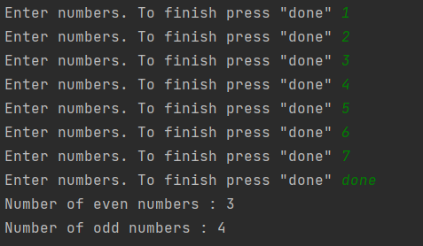

- Write a Python program that prints all the numbers from 0 to 100 except numbers which are divided by 7.
Note: Use 'continue' statement.

- Write a Python program to get the Fibonacci series between 0 to 50.
Note : The Fibonacci Sequence is the series of numbers :
0, 1, 1, 2, 3, 5, 8, 13, ....
Every next number is found by adding up the two numbers before it.
Expected Output : 1 1 2 3 5 8 13 21 34

- Write a Python program to find middle number out of three numbers.
Examples:

Input : a = 20, b = 30, c = 40
Output : 30

Input : a = 12, n = 32, c = 11
Output : 12

- Write a Python program to calculate the sum and average of n integer numbers (input from the user). Input 0 to finish.

- Write a Python program to construct the following pattern, using a nested loop.
Expected Output:

1
22
333
4444
55555
666666
7777777
88888888
999999999

